Amazon Bedrock AgentCore - Series

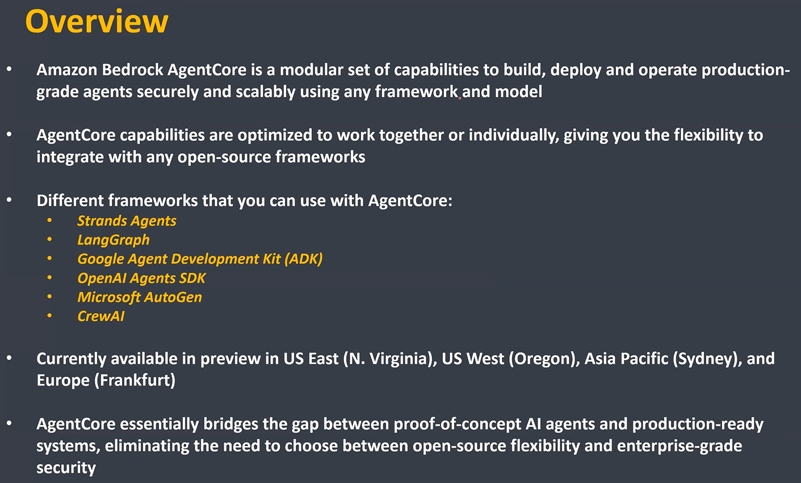

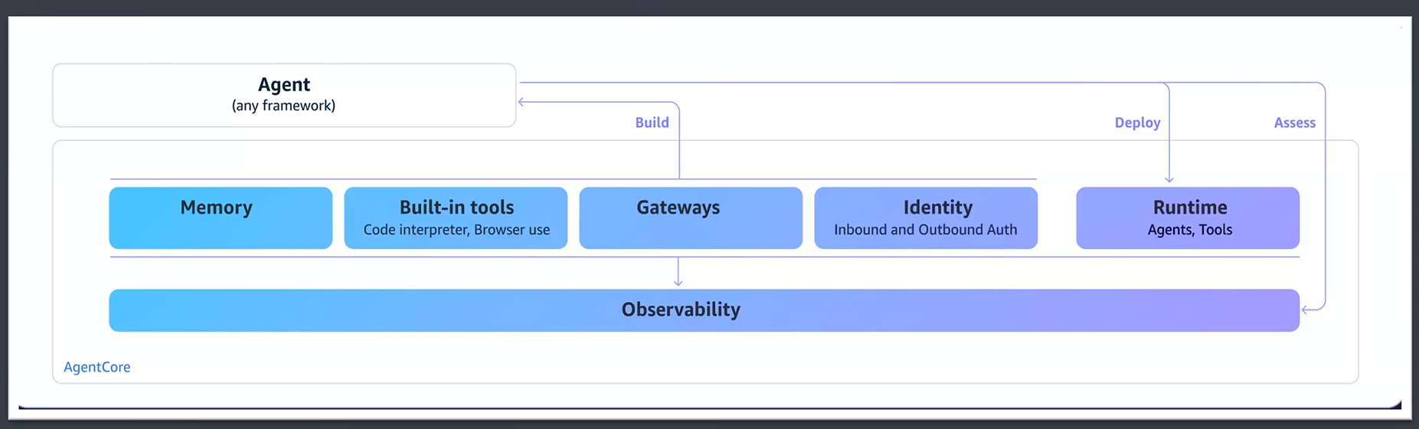

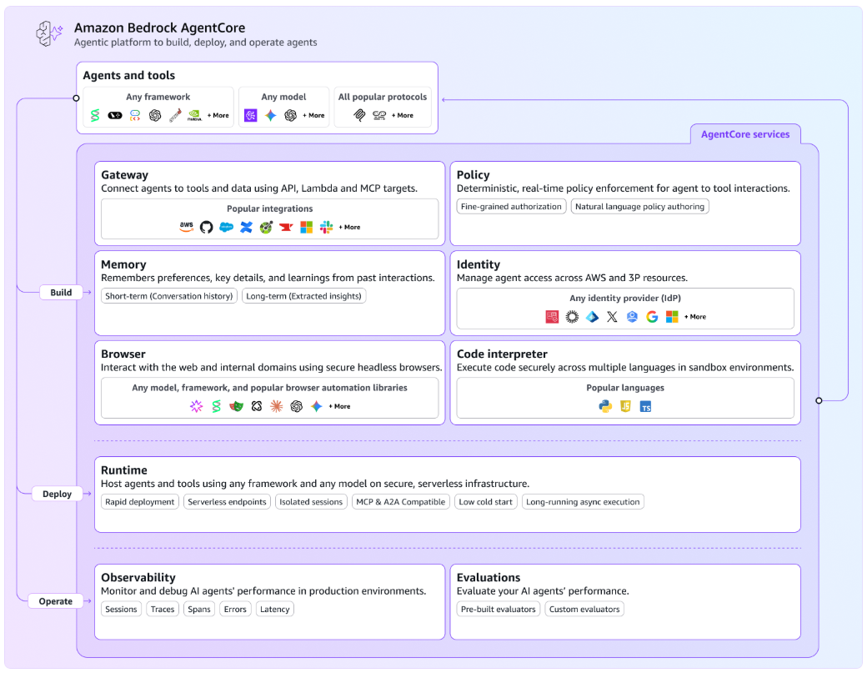

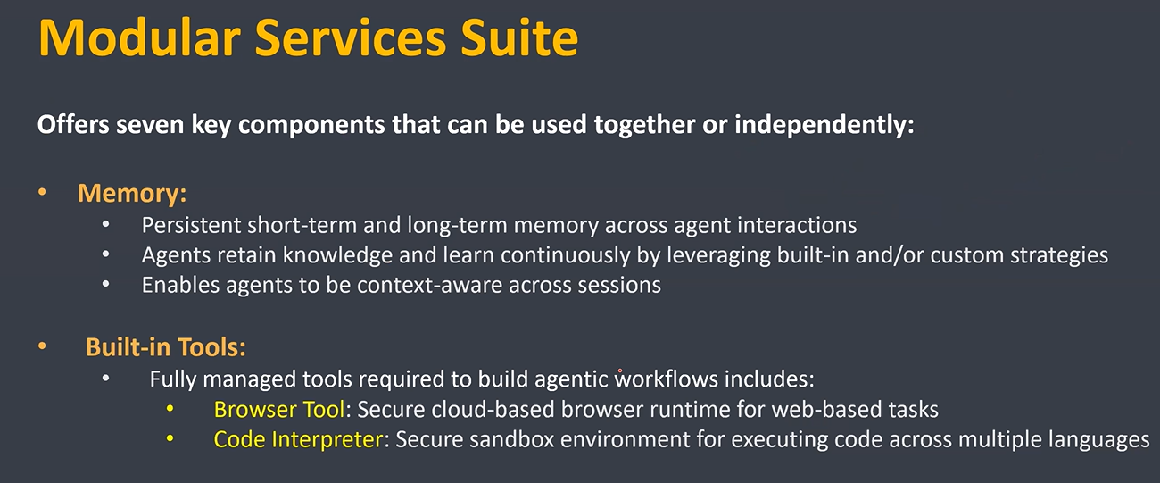

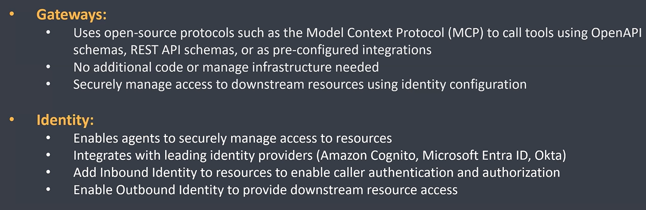

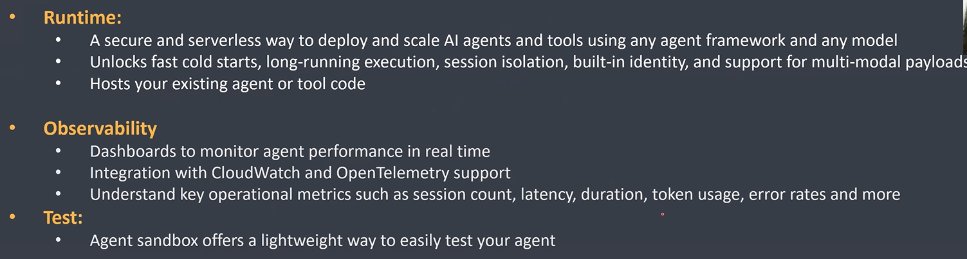

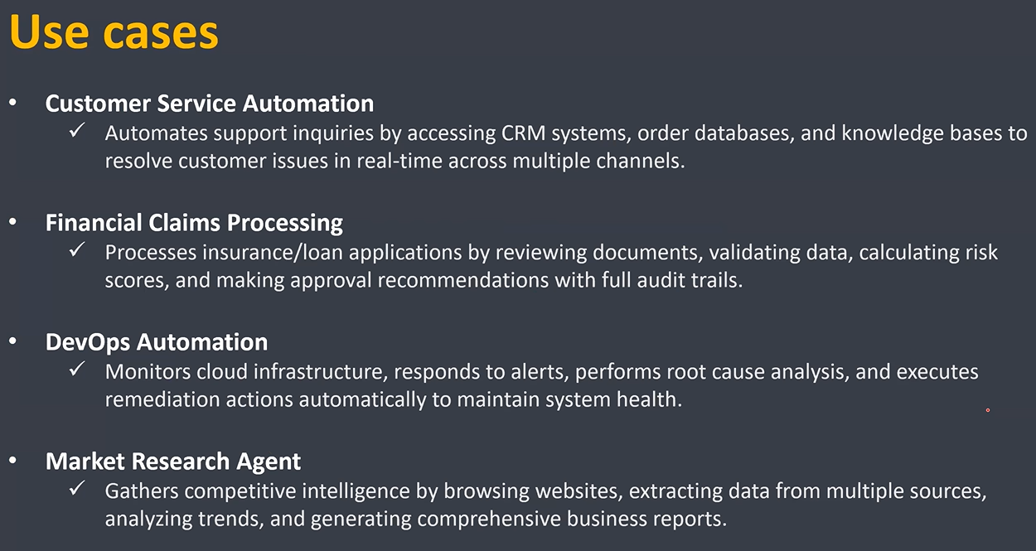

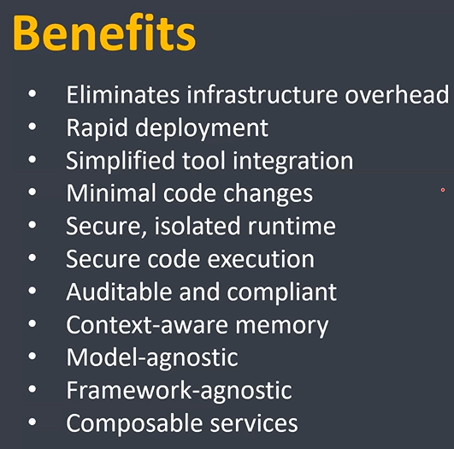

Part 2 – AgentCore Runtime

Reference:

<https://docs.aws.amazon.com/bedrock-agentcore/latest/devguide/agents-tools-runtime.html>

<https://docs.aws.amazon.com/bedrock-agentcore/latest/devguide/runtime-how-it-works.html>

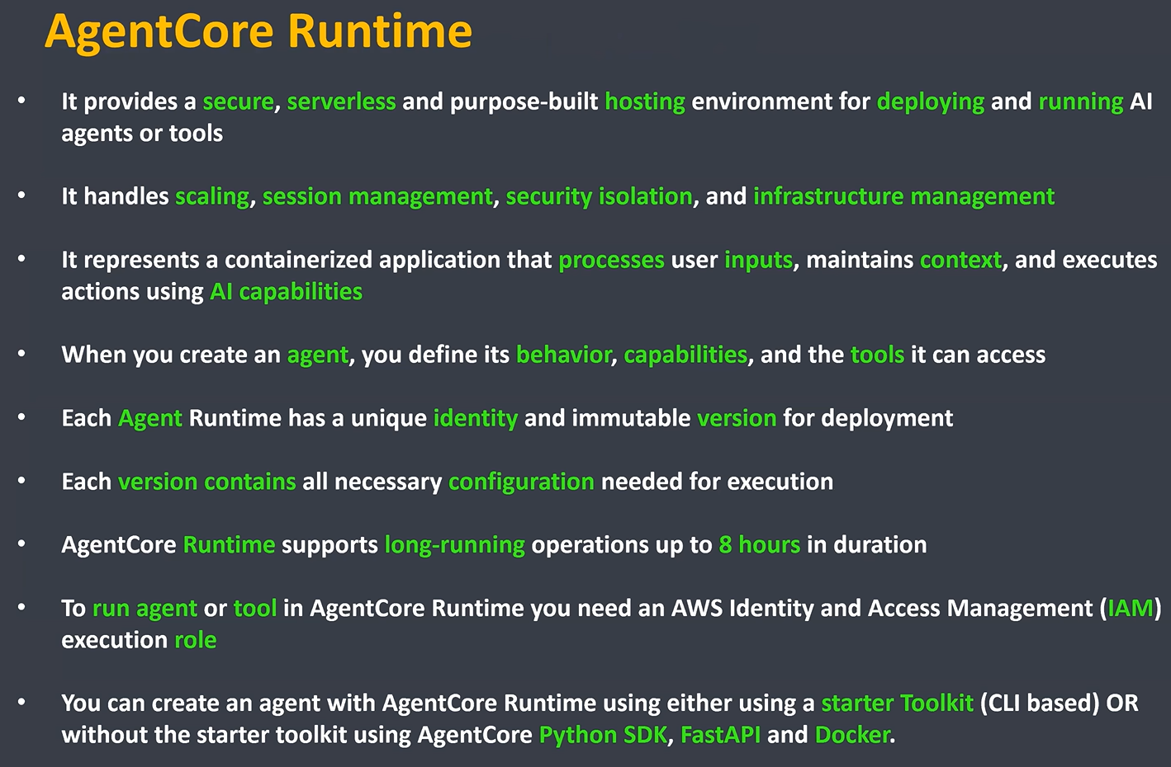

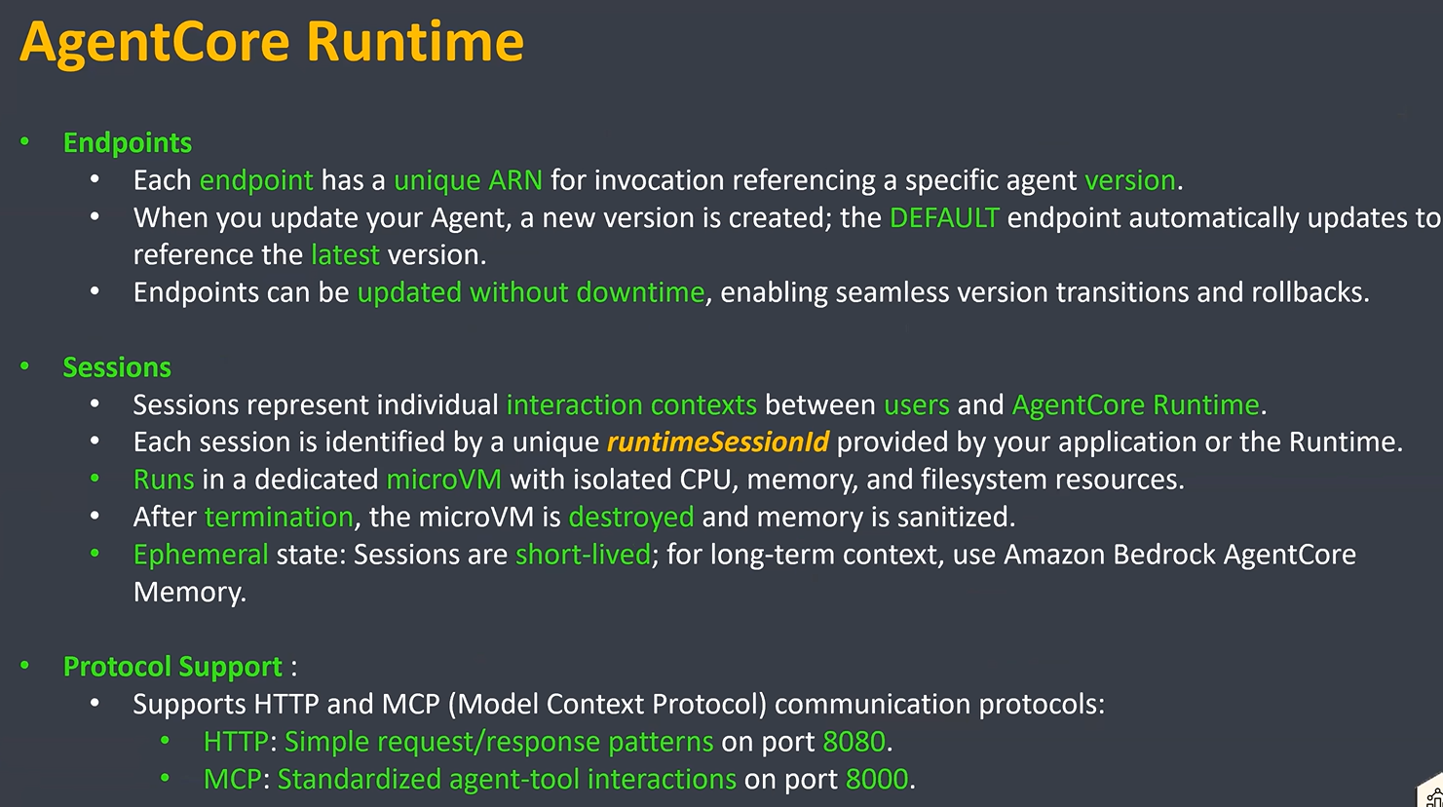

Part 3 – Deploy a simple agent with AgentCore Starter Toolkit

References:

<https://github.com/nasha2878/AmazonBedrockAgentCore>

<https://docs.aws.amazon.com/bedrock-agentcore/latest/devguide/what-is-bedrock-agentcore.html>

<https://docs.aws.amazon.com/bedrock-agentcore/latest/devguide/runtime-permissions.html#runtime-permissions-starter-toolkit>

<https://docs.aws.amazon.com/bedrock-agentcore/latest/devguide/runtime-troubleshooting.html>

